**School of Isolated and Distance Education**

**SEMESTER ONE EXAMINATION 2019**

**COMPUTER SCIENCE YEAR 11 CSC**

**Student Name: ____________________________________________**

**SIDE Teacher: ____________________________________________**

**SIDE Student Coordinator: ____________________________________________**

**Base School: ____________________________________________**

**SUPERVISOR’S DECLARATION**

I declare that this examination paper has been completed by the student named above. The time and resource restrictions have been observed and the student has NOT accessed notes, texts, reference books, the internet, a computer, a calculator or a mobile phone unless otherwise specified. I understand that breaches of the examination rules could lead to an examination paper being cancelled or having an examination mark significantly lowered.

**Supervisor’s Name: ___________________________________________**

**Signature: _________________________ Date _____________**

**TIME ALLOWED FOR THIS <<PAPER/SECTION>>**

Reading Time ten minutes

Working Time two and a half hours

**MATERIALS REQUIRED/RECOMMENDED FOR THIS PAPER**

**To be provided by the supervisor**

This Question/Answer Booklet

**To be provided by the candidate**

Standard items: pens, pencils, eraser, correction fluid/tape, ruler, highlighters

Special items: non-programmable calculators, MATHOMAT and/or Mathaid and/or any system flowchart template

**NO OTHER ITEMS MAY BE TAKEN INTO THE EXAMINATION ROOM**

**IMPORTANT INFORMATION FOR CANDIDATES**

No other items may be taken into the examination room. It is your responsibility to ensure that you do not have any unauthorised notes or other items of a non-personal nature in the examination room. If you have any unauthorised material with you, hand it to the supervisor before reading any further.

**Structure of this paper**

|  |  |  |  |  |  |
| --- | --- | --- | --- | --- | --- |
| Section | Number of questions available | Number of questions to be answered | Suggested working time (minutes) | Marks available | Percentage of examination |
| Section One Short answer | 20 | 20 | 60 | 120 | 40 |
| Section Two Extended answer | 3 | 3 | 90 | 69 | 60 |
| **Total** | | | | | 100 |

**Section One: Short answer 40% (120 Marks)**

This section contains **20** questions. You must answer **all** questions. Write your answers in the spaces provided.

Supplementary pages for planning/continuing your answers to questions are provided at the end of this Question/Answer booklet. If you use these pages to continue an answer, indicate at the original answer where the answer is continued, i.e. give the page number.

Suggested working time: 70 minutes.

**Question 1 (2 marks)**

Describe one difference between a context diagram and a level 0 data flow diagram.

**Question 2 (12 marks)**

1. The Central Processing Unit (CPU) has a number of components. Describe the role of each of the following components:

Arithmetic Logic Unit (ALU):

Control Unit (CU):

Registers:

1. The incomplete diagram below represents the Central Processing Unit (CPU) and the fetch-execute cycle. (3 marks)

Fill in the boxes (??) with the components of the CPU. RAM has been placed in the diagram for you.

**CENTRAL PROCESSING UNIT**

??

**??**

**RAM**

??

(c) State the function of the system clock. (1 mark)

1. In relation to computer architecture, what are buses? (1 mark)

1. State the function of program counter. (1 mark)

**Question 3 (11 marks)**

1. Identify and describe the four steps in the fetch-execute cycle. You may use the diagram in Question 2 above to assist you. The arrows represent the fetch-execute cycle. (8 marks)

1. The descriptions below relate to the role of the components in the fetch-execute cycle. Match the descriptions to each of the components. (3 marks)

* The memory address of the instruction to be fetched is transmitted from the program counter to the RAM through the address bus.
* This is a register in the CPU which contains the memory address of the next instruction to be processed.
* The data is transmitted from RAM back to the instruction register in the CPU through the data bus.

Program counter:

The address bus:

The data bus:

**Question 4 (12 marks)**

1. Describe what occurs in each of the following stages of the Systems Development Life Cycle (SDLC). (6 marks)

Preliminary analysis (Stage 1):

Design (Stage 3):

Evaluation and maintenance (Stage 6):

1. Describe the purpose of data gathering when applying the Systems Development Life Cycle (SDLC).

(2 marks)

1. Describe **two** techniques that can be used to gather data. (4 marks)

1. State **two** tools/techniques that can be used in the system design stage (Stage 3) of the Systems Development Life Cycle (SDLC). These tools/techniques are used to describe the system under consideration.

**Question 5 (16 marks)**



* Specifications for the device is as follows:
* 2.5GHz Intel Core i7-7660U (dual-core, 4MB cache, up to 4GHz with Turbo Boost), Intel Iris Plus Graphics 640, RAM 16GB LPDDR3, 12.3 inch, 2,736 x 1,824 PixelSense display, 512GB SSD.

1. Use the specifications for the device provided above to fill in the details under the appropriate headings in the table below:

|  |  |
| --- | --- |
| **Display Size**: | **CPU**: |
| **Screen Resolution**: | **Primary memory:** |
| **Secondary storage:** | **Processor Speed:** |

1. Describe the following terms.

CPU:

Screen resolution:

Primary memory:

Secondary storage:

Cache:

**Question 6 (2 marks)**

State the difference between private key and public key encryption.

**Question 7 (6 marks)**

In authentication, the user or computer has to prove its identity to the server or client.

Describe the following methods of authentication.

Passwords:

Biometrics:

Digital signatures:

**Question 8 (10 marks)**

Describe the following database terms.

Data integrity:

Data redundancy:

Atomicity:

Record:

Relation:

**Question 9 (7 marks)**

1. An entity relationship (ER) diagram for ***student-subject*** selections as shown below is a many-to-many relationship, and is such not acceptable in a relational database.

Draw an ER diagram to resolve the many-to-many relationship in the space provided below. The primary key for the Student entity and the Subject entity has been provided.

Include the following:

* The names of all entities.
* The relationships.
* The cardinality.

**SubjectID**

Student

Subject

M

N

study

**StudentID**

Cardinality:

1. Identify the Primary key for the associative entity. (1 mark)

Primary key:

1. Provide two possible foreign keys for your ER diagram. (2 marks)

Foreign key one:

Foreign key two:

**Question 10 (9 marks)**

1. Give an example of each data type listed in the table below. The first has been done for you.

|  |  |
| --- | --- |
| Data type | Example |
| Number | **340** |
| Date |  |
| Currency |  |
| Text (String) |  |
| Boolean (true/false) |  |

1. Match the following definitions with the terms in the table below. (4 marks)

**Database Object**:

* Validation Rules
* Forms
* Reports
* Queries

|  |  |
| --- | --- |
| **Definition** | **Database Object** |
| Part of a database that allows the user to easily input data. |  |
| This lets you search a database and is usually viewed on a computer screen. |  |
| Check data which are or are not allowed. |  |
| Formatted and organised presentation of data, useful for decision making. |  |

1. Consider the database object shown below. (1 mark)

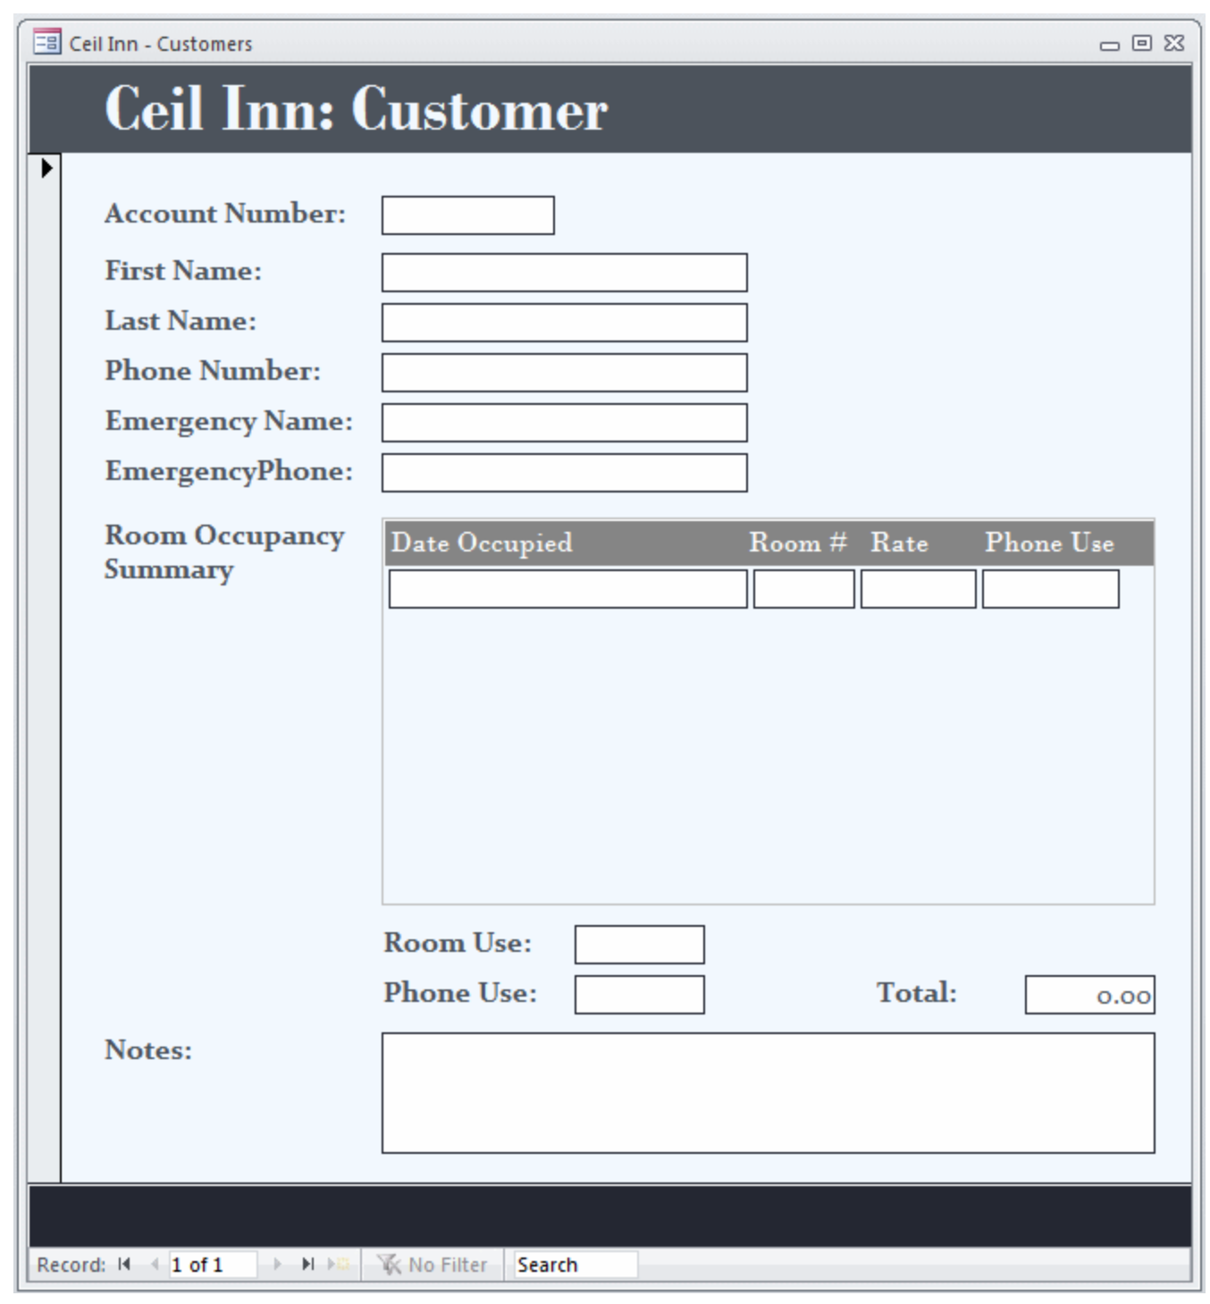

What type of database object is this?

**Question 11 (4 marks)**

|  |  |  |  |  |
| --- | --- | --- | --- | --- |
| **TourID** | **TourName** | **TotalCost** | **NumberofDays** | **Accomodation** |
| 101 | AlaskaCanada | $5000 | 15 | Yes |
| 201 | SouthAmerica | $4400 | 12 | Yes |
| 301 | NewYork | $5200 | 14 | No |
| 401 | Venice | $4000 | 10 | Yes |

Describe the following database terms and give an example of each based on the table above.

Field:

Example:

Record:

Example:

**Question 12 (5 marks)**

**Use the following Data Flow Diagram (DFD) to answer the following questions.**

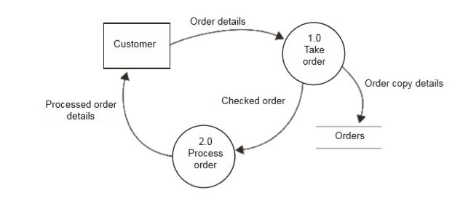

**Deliveries**

**Checked order**

**details**

**Updated order**

**details**

1. State what **Customer** represents in the Data Flow Diagram (DFD). (1 mark)

1. State what **1.0 Take order** represents in the Data Flow Diagram (DFD). (1 mark)

1. State what **Orders** represent in the Data Flow Diagram (DFD). (1 mark)

1. Identify **one** error in the Data Flow Diagram (DFD) **and** state why this is incorrect.

(2 marks)

**Question 13 (7 marks)**

1. At the smallest scale in the computer, information is stored as bits and bytes. How many bits equal a byte? (1 mark)

(b) Complete the table below which shows the abbreviations and units of measure for storage capacities. The first row has been completed for you. (6 marks)

|  |  |  |
| --- | --- | --- |
| **Unit** | **Abbreviation** | **Approximate Decimal Size** |
| kilobyte | KB | 1 000 bytes |
| megabyte |  |  |
| gigabyte |  |  |
| terabyte |  |  |

**Question 14 (2 marks)**

A large supermarket’s ICT system collects customer information to study their purchasing trends. Describe one ethical consideration with this.

**Question 15 (3 marks)**

1. State the purpose of an ICT code of conduct. (1 mark)

1. List **two** things that may be included in an ICT Code of Conduct. (2 marks)

**Question 16 (10 marks)**

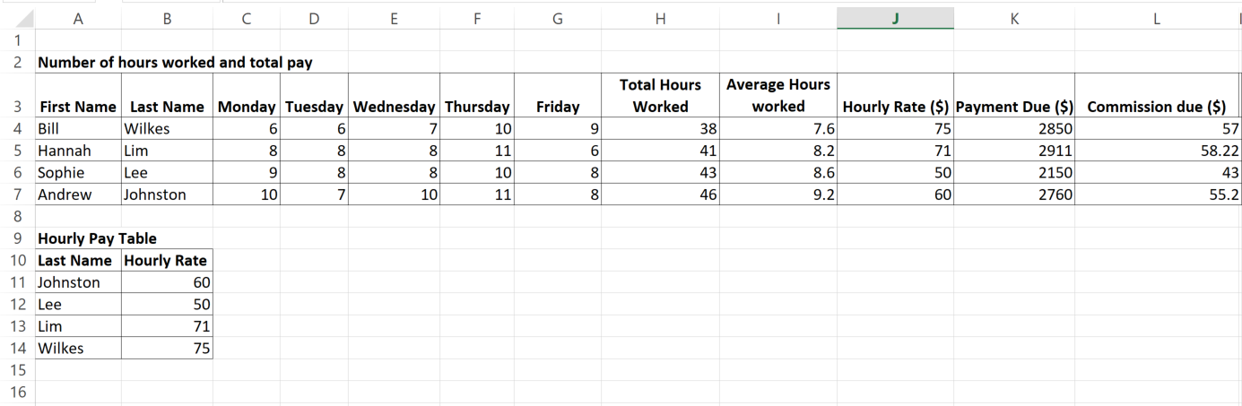

Refer to the diagram above to answer the following questions:

1. Write the formula that would appear in Cell H4 to calculate the Total Hours Bill Wilkes worked from Monday to Friday.

1. Write the formula that would appear in Cell I4 to calculate the Average Hours Bill Wilkes worked from Monday to Friday.

1. To obtain the Hourly Rate for Bill Wilkes, select the correct formula for cell J4 using the Hourly Pay table.

1. Describe the following spreadsheet terms. Give examples from the spreadsheet data provided above to support your explanation.

Label:

Example:

Functions:

Example:

Cell:

Example:

**Question 17 (2 marks)**

1. State the purpose of database documentation. (1 mark)

(b) Provide one example of database documentation. (1 mark)

**End of Section One**

**Section Two: Extended answer 60% (69 Marks)**

This section has **three** questions. Answer **all** questions. Write your answers in the spaces provided.

Supplementary pages for planning/continuing your answers to questions are provided at the end of this Question/Answer booklet. If you use these pages to continue an answer, indicate at the original answer where the answer is continued, i.e. give the page number.

Suggested working time: 110 minutes.

**Question 21 (35 marks)**

Read the case study below as background to all the questions in this section.

**Case Study**

The Perth Sports Club (PSC) plans to introduce an online system to sell tickets for all games to be held at the PSC stadium. They intend to quickly release a sample system which will be tested by a group of users to get feedback.

All customers need to create an account and their login details before using the system.

The following describes the online PSC Ticket System.

* Customer inputs login details
* The customer details are verified against the Customer database
* Once verified, Customer selects tickets required from available options in the Tickets database
* Customer confirms ticket order which is stored in the Orders database
* Customer pays via credit card
* The tickets are then allocated and the Orders database is updated

(a) Systems Development Life Cycle (SDLC) and Prototype are two types of system development methodologies that are used in project management. Describe these two methods below. (4 marks)

Systems Development Life Cycle (SDLC):

Prototype:

(b) Recommend and justify the system development methodology most suitable for PSC. (3 marks)

1. When describing a system, analysts refer to the ‘system boundary’. Describe the purpose of a system boundary. (2 marks)

(d) On a Context Diagram you never show ‘Data Stores’. Explain why. (2 marks)

(e) Complete the **Context Diagram** for the online PSC Ticket System. (6 marks)

Customer

Customer

(d)Complete the Level 0 Data Flow Diagram (DFD) for PSC Online Ticket System

(18 marks)

Customer

Customer

Customer

**Question 22 (12 marks)**

1. There are **four** ways that the Perth Sports Club (PSC) can implement the new computerised system to manage the online ticket system:

Direct Cut, Parallel, Pilot and Phased.

Briefly describe each of the system implementation methods and give **one** advantage and **one** disadvantage of applying each method.

1. **Direct Cut**

Description:

Advantage:

Disadvantage:

1. **Parallel**

Description:

Advantage:

Disadvantage:

1. **Pilot**

Description:

Advantage:

Disadvantage:

1. **Phased**

Description:

Advantage:

Disadvantage:

**Question 23 (22 marks)**

The following description describes the ERD for the PSC Online Ticket System:

* One customer can place many orders but each order is for one customer only on a particular date.
* An order can consist of many tickets but each ticket belongs to one order.
* Each ticket relates to one event only

Complete the ER Diagram below for the PSC Online Ticket System by doing the following:

1. Using Chen’s notation for ER Diagram (1 mark)

(a) Fill in the name of the four unnamed entities on the ER Diagram. (4 marks)

1. Fill in the three relationships. (3 marks)

(c) Include the cardinality for the ER diagram. (3 marks)

(d) Underline the **primary key(s**) for each entity on the ER Diagram. (The Customer entity has already been completed for you). (3 marks)

(e) Determine any foreign keys, placing **FK** after the field on the ER Diagram. (3 marks)

CustomerID

FirstName

LastName

DOB

Email

(f) Complete the data dictionary below for the Customer Entity (5 marks)

|  |  |  |  |  |
| --- | --- | --- | --- | --- |
| **Element name** | **Data type** | **Size/ Format** | **Description** | **Constraint** |
| CustomerID |  | 6 | Unique identifier for each student | Required. Automatically created when record added |
| FirstName | String | 25 | Given name of customer |  |
| LastName | String | 25 | Surname of customer | Required |
| Date of Birth | String |  | Date of birth of customer | Required |
| Email | String | 30 |  | Required. An email confirmation is given for lunch order |

**End of questions**

Supplementary page

Question number:

Supplementary page

Question number:

Supplementary page

Question number: